

**Operating System**

**Lab # 02**

**Name: Zainab Bibi**

**Sap Id: 46462**

**Batch: BSCS 5thsemester**

**Submitted to: Mam Kausar**

**Question # 1**

To begin, you need to set up a structured directory layout in your home directory. Start by creating two directories named OS_Course and OS_Lab. These directories will serve as the main folders for organizing your OS Lab tasks. After creating these directories, switch to the OS_Lab directory. Within OS_Lab, create three more directories named LAB_Class_Task, LAB_Activities, and Lab_Practice. Each of these directories will help you categorize different aspects of your lab work. Once you have created these directories, go into the Lab_Practice directory and create a file named example.cpp. This file should be empty and will be used for practice later. Finally, move back to your home directory. Make sure to take screenshots of each step, including the creation of directories, the file creation, and your navigation commands to document your process.

Note: Include screenshots, where required to illustrate your explanation.

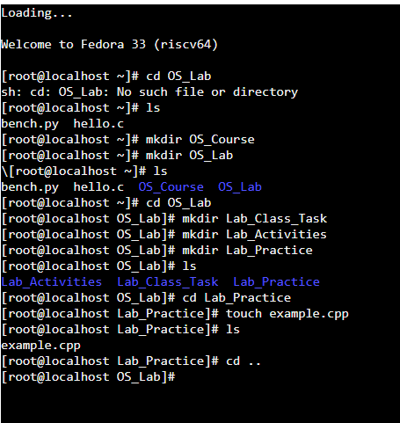

**Question # 02**

Finally, you need to understand the concepts of absolute and relative paths. Explain the difference between these two types of paths and provide an example of each. This will help you navigate directories more effectively. If you are currently in the Lab_Practice directory, describe the relative path to access the LAB_Activities directory. This will test your understanding of how to move between directories using relative paths.

Note: Include screenshots, where required to illustrate your explanation.

**Absolute Path:**

The complete path from the root directory, always starting with /.

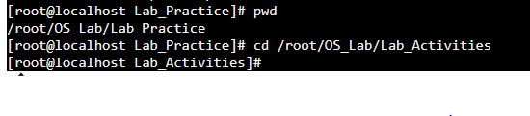

**Relative Path:**

The path based on our current location, it doesn’t start with /.

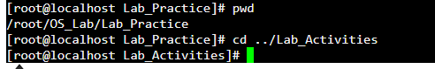

**Question # 03**

Imagine you’re working on your computer when you suddenly need to turn it off quickly. You press and hold the power button until the computer shuts down completely. After an hour, you turn the computer back on, and it quickly shows the login screen or desktop.

Why does your computer start up smoothly and quickly after being turned off? Describe the process that happens between powering off the computer and seeing the login or desktop screen. What steps does the computer go through to get everything ready in a short amount of time?

**Answer:** When you hold the power button to turn off your computer, it may save your system state to the hard drive. This is called fast startup.

**1. Save State:** Before shutting down, it saves what’s running.

**2. Power Off:** The computer turns off completely.

**3. Quick Start:** When you turn it back on, it reloads the saved state from the hard drive.

**4. Ready Fast:** It skips extra steps and quickly shows the login or desktop screen.

Basically, it’s like the computer is waking up from sleep, not starting fresh!